**FYP SRS Document**

Final Year Project

Software Requirement Specification

For

**Trafficviz**

(BSCS Fall 2017-2021)

By

128

|  |  |  |  |  |
| --- | --- | --- | --- | --- |
| S# | **Name** | **Registration #/Roll #/Section** | **Mobile #** | **Project ID** |
| 1. | Muhammad Umar Farooq | Fa-2017/BSCS/317 - G | 0301-5339926 |  |
| 2. | Muhammad Usama Javed | Fa-2017/BSCS/323 - G | 0306-4718518 |

**Supervised by:**

Ma’am Sowaiba Khan **___________________ (**Signature**)**



Department of Computer Science

Lahore Garrison University

Lahore

Table of Contents

Introduction 1

Purpose: 1

Document Convention: 1

Intended Audience and Reading Suggestions: 2

Project Scope: 2

Overall Description 2

Product Perspective: 2

Product Functions: 2

User Classes and Characteristics: 2

Operating Environment: 2

Software used: 2

Hardware Tools: 3

Design and Implementation Constraints 3

User Documentation 3

External Interface Requirements 3

User Interfaces: 3

Software Interface: 4

MATLAB 4

Python 3.7 4

Arduino IDE 4

MySQL Workbench 4

Hardware Interface: 4

GSM – Global System for Mobile Communication 4

GPS - Global Positioning System 5

Camera 5

LED: 5

SENSOR 5

Communications Interfaces 6

System Feature 6

Functional requirements 8

Other non-functional requirements 8

Performance Requirements 8

Security Requirements 9

Software quality attributes 9

Accessibility 9

Reliability & Availability 9

### Business Rules……………………………………………………………….……………….9

References 10

# Introduction

## **Purpose:**

Hologram is a technique that record pattern of interference produced by a scattered light (just like laser) and reproduce the 3D image. If the signal turns off due to electricity or any other reason than the traffic warden can control all the traffic through hologram from office. Through the hologram the traffic warden will present on road and he will manage all the traffic manually but in real he’s in his office.

Traffic management is a big issue now a days in our society because the growth of population and vehicle. We loss many lives due to emergency rescue vehicle such as fire brigade and ambulance get stuck in traffic jam or traffic signal and waste their time. Our aims to detect the ambulance using Digital Image Processing (DIP) and turn on the green signal for ambulance route and another signal will goes red. In this system we give access to ambulance driver if ambulance is away from signal and there’s no camera to detect ambulance so he can use wireless system to communicate with traffic controller.

Rate of accident has risen due to more traffic. The main objective of traffic vision to detect the accident and inform the traffic controller and rescue team immediately through wireless communications technique. GSM module will be used to send message in short time. When the accident occurs, the vibration sensor will be activated and send information to the rescue and traffic teams. Through the GPS system we will find where the accident occurs. The accident can be detected by a vibration sensor which is used as major module in the system.

## **Document Convention:**

Following are the requisite of this SRS document

**Heading level 1**

The heading should be written in bold. The font size and style should be 18 and Time new roman.

**Heading level 2**

The heading should be written in bold. The font size and style should be 16 and Time new roman

**Heading level 2**

The heading should be written in bold. The font size and style should be 12 and Time new roman

**Para Style**

In paragraph writing the font size is 12 with 1.5 line spacing

**Margins**

1-inch from right side and 1.25 inches from left side

## **Intended Audience and Reading Suggestions:**

This project is a prototype for the ambulance & Accident detection and mixed reality (Hologram).  It is restricted within the traffic controllers and hospital management. Hologram has been implemented under Traffic controllers. This project is useful for the traffic controllers and as well as to the vehicle’s driver.

## **Project Scope:**

The overall goal of our project is to device a system that will ultimately control the increasing traffic load along with reducing the risk of accidents. Our project is way better than the previous because a single device can help us to minimize the effect of several problems. Our single device can be used to detect the accidents and their reporting and control the traffic problems like over-speeding and flow of traffic.

# Overall Description

This part will explain our project in detail.

## **Product Perspective:**

Increasing load of motor vehicles on the roads results in higher accidents rates as well obstruction in the traffic flow. In this system, we aim to add 3 features.

## **Product Functions:**

* A hologram will be placed in the traffic system. It will help a traffic warden to manage all the traffic from his office through the hologram.
* Second feature is to detect the ambulance using DIP and GSM technology. A CMOS image sensor is placed in traffic system to detect ambulance and change the signal light to green for ambulance route.
* Third feature is to detect the accident and inform the rescue team and traffic police immediately.

## **User Classes and Characteristics:**

* Medical Centers
* Traffic Police department
* Police Department
* Common people

## **Operating Environment:**

### Software used:

1. Operating System: Windows 10 or higher.
2. Front End: Implementation on hardware/simulation
3. Back End: My SQL 2008, PHP, Python, MATLAB, DIP

### Hardware Tools:

1. Hologram Technology
2. GSM and GPS Module
3. Traffic signals
4. Motor vehicles
5. Ambulance
6. Sensors
7. Camera
8. LEDs
9. Batteries
10. Tracker
11. Lasers
12. LCD: LCD shows the Latitude and Longitude, at the time of accident it shows notifications.
13. Power Adapter: 12 Volt 2A adapter is used to give power to system.
14. LM 317
15. Resistance: 1.1 K 1 PC
16. Resistance: 330 ohm 2 PCs
17. Resistance: 470 ohm 1 PC
18. Preset: 10k 2 PCs
19. Momentary Switch 2 PCs

## **Design and Implementation Constraints**

1. Firebase database, Allocation schema, Hologram, Google MAP API

2. Python SDK, SQL commands for above queries/applications

## **User Documentation**

* User guide
* Tutorials
* YouTube channel

# External Interface Requirements

## **User Interfaces:**

Front-end software: Vb.net version,

Back-end software: SQL+

## The application GUI provides menus, toolbars, buttons, containers, grids allowing for easy control by a keyboard and a mouse.

## **Software Interface:**

### MATLAB

It is a software numerical computing environment which allows matrix manipulation, implementation of image processing algorithms? It is the software that combines a computer environment turned for iterative evaluation and layout techniques with a programming language that express matrix and array mathematics directly.

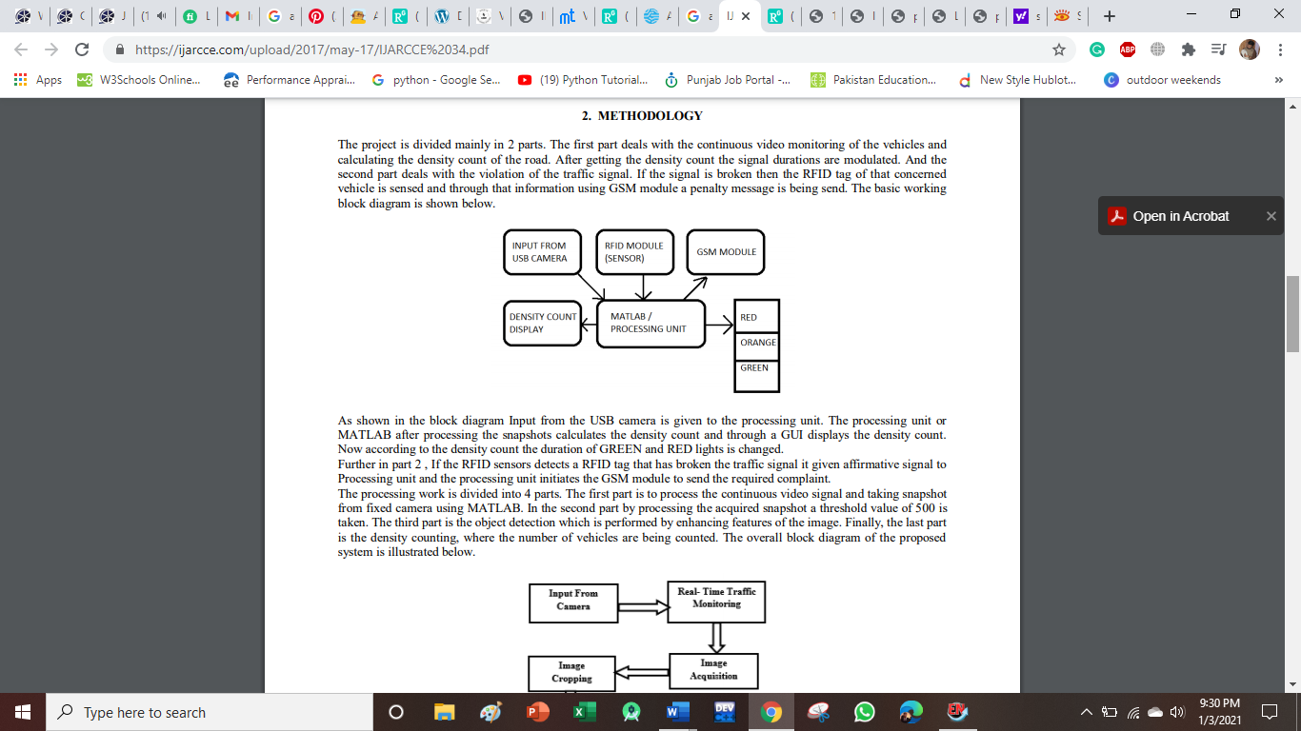

### Python 3.7

The majority of the system was designed in Python. Python is a general purpose, interpreted, object oriented, high level programming language. Owing to its simple programming syntax, code readability python was chosen as the preferred language for the system to be programmed. The other factor to be considered it that, it has an abundance of prebuilt modules and packages that make it easier to program.

### Arduino IDE

Arduino IDE is an Integrated Development Environment for programming on Arduino Boards, which makes it easy to write code and upload code to the board. The environment is written in Java and is based on Processing and other open-source software.

### MySQL Workbench

MySQL is an open-source relational database management system. SQL is short for “Structured Query Language”

## **Hardware Interface:**

### GSM – Global System for Mobile Communication

GSM is used as a media which is used to control and monitor the transformer load from anywhere by sending a message. It has its own deterministic character. Hence no need to waste time by manual operation and transportation. Hence it is considered as highly efficient communication through the mobile which will be useful in industrial controls, automobiles, and appliances which would be controlled from anywhere else. It is also highly economic and less expensive; hence GSM is preferred most for this mode of controlling. Hence this automatic system is more efficient and less expensive and more convenient to use from were ever possible. Hence can be preferred mode of communication for controlling purpose.

### GPS - Global Positioning System

GPS is used in vehicles for both tracking and navigation. Tracking systems enable a base station to keep track of the vehicles without the intervention of the driver where, as navigation system helps the driver to reach the destination. When an accident occurred in any place then GPS system tracks the position of the vehicle and sends the information to the particular person through GSM by alerting the person through SMS or by a call. GPS module sends the data related to tracking position in real time, and it sends so many data in NMEA format. NMEA format consists several sentences.in which we only need one sentence. This sentence starts from $GPGGA and contains the coordinates, time and other useful information. This GPGGA is referred to GLOBAL POSITIONING SYSTEM FIX DATA.

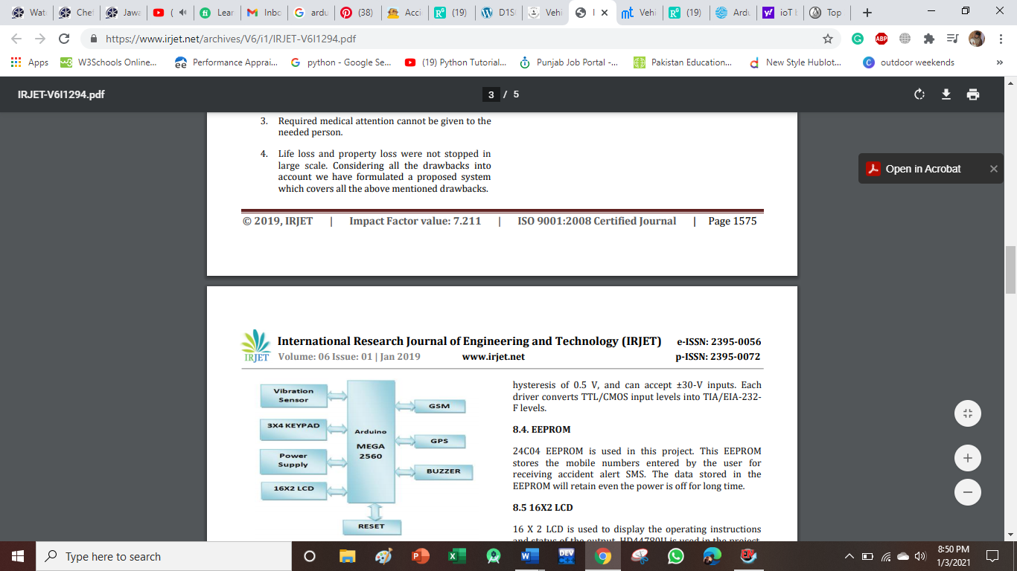

### Camera

A camera is an optical instrument used to record pictures. At their generally fundamental, cameras are fixed boxes (the camera body) with a little opening (the gap) that let light in to catch a picture on a light-touchy surface (typically photographic film or an advanced sensor). Cameras have different instruments to control how the light falls onto the light-touchy surface. Focal points center the light entering the camera, the size of the opening can be enlarged or limited to give pretty much light access to the camera, and a screen instrument decides the measure of time the photograph touchy surface is presented to the light

### LED:

LED means "light emitting diode." A diode is an electrical part with two terminals which lead the power just one way. With an electrical flow, the diode radiates a brilliant light around the little bulb. It is a p–n intersection diode that radiates light when enacted. At the point when a reasonable voltage is applied to the leads, electrons can recombine with electron openings inside the gadget, discharging vitality as photons

### SENSOR

A piezoelectric sensor is used as accident detection sensor. A piezoelectric transducer has very high DC output impedance and can be modeled as a proportional voltage source and filter network. The voltage V at the source is directly proportional to the applied force, pressure, or strain. The output signal is then related to this mechanical force as if it had passed through the equivalent circuit.

## **Communications Interfaces**

GSM Module is used to communicate with the mobile device or computing machine for accident detection. For Hologram and ambulance detection we use internet/cloud to communicate in this project.

# System Feature

This part will illustrate the features of our model in detail with their intendent uses and accompanied risks

|  |  |  |  |
| --- | --- | --- | --- |
| **Sr #** | **System Feature** | **Description** | **Priority** |
| 1 | **Accident detection by GMS Module** | Traffic vision to detect the accident and inform the traffic controller and rescue team immediately through wireless communications technique. GSM module will be used to send message in short time. When the accident occurs, the vibration sensor will be activated and send information to the rescue and traffic teams. Through the GPS system we will find where the accident occurs. The accident can be detected by a vibration sensor which is used as major module in the system | High |
| **Stimulus Sequence and Response** | | | |
|  | | | |
| 2 | **Ambulance detection** | To detect the ambulance using Digital Image Processing (DIP) and turn on the green signal for ambulance route and another signal will goes red. In this system we give access to ambulance driver if ambulance is away from signal and there’s no camera to detect ambulance so he can use wireless system to communicate with traffic controller | High |
| **Stimulus Sequence and Response** | | | |
|  | | | |
| 3. | **Traffic Control by Hologram** | If the signal turns off due to electricity or any other reason than the traffic warden can control all the traffic through hologram from office. Through the hologram the traffic warden will present on road and he will manage all the traffic manually but in real he’s in his office | High |
| **Stimulus Sequence and Response** | | | |
|  | | | |

**TECHNOLOGY** **PRICE**

Hologram Technology 20,000-25,000 Rs

GSM and GPS Module 8,500 Rs

Traffic Signal (6) 700 per piece

Motor vehicle (3) 700 Per vehicle

Ambulance 700

Sensors (5) 800 per sensor

Camera(4) 8000

LEDs(15) 800

Batteries (10) 5000

Tracker (3) 3000

Lasers 700

LCD 10000

Power adapter 500

Resistance 200

Preset 10 50

Total 75,000 to 80,000

## **Functional requirements**

### Accident detection requirement

1. Provide comprehensive User Web Portal. The system shall display user login and able to access view of real time vehicle location.
2. Provide comprehensive Admin Web Portal. The system shall display Admin login and able enter customer/company.
3. Provide personalized profile. The system shall display the detailed information about the selected vehicle information about location.
4. Provide Customer Support. The system shall provide online help, FAQ‟s customer support, and sitemap options for customer support. The system shall display the customer support contact numbers on the screen. The system shall display the FAQ‟s upon request.

### Traffic Control requirements

1. Each of the projectors provides a tracking device which is keyed to the user, enabling the recovery of the projector in the event it becomes lost or stolen.
2. Each projector also provides a receiver, an internal antenna, a microprocessor and a memory device, enabling secured control of the projector from the user's laptop or other electronic device, either with a password or by some other means. The memory device stores one or more images which may be created by the projector

### Ambulance detection

1. System should be provided with the clear input ambulance video which will be processed by our system

# Other non-functional requirements

## **Performance Requirements**

1. The product shall be based on web and has to be run from a web server.

2. The product shall take initial load time depending on internet connection strength which also depends on the media from which the product is run.

3. The performance shall depend upon hardware components of the client/customer.

## **Security Requirements**

1. Data Transfer: The system shall use secure sockets in all transactions that include any confidential customer information.

2. The system shall not automatically log out all customers after a period of inactivity.

3. The system shall confirm all transactions with the customer’s web browser.

4. The system shall not leave any cookies on the customer’s computer containing any of the user’s confidential information.

## **Software quality attributes**

### Accessibility

1. The system shall provide Web access.

2. The system shall provide Mobile Apps support.

### Reliability & Availability

1. Back-end Internal Computers: The system shall provide storage of all databases on redundant computers with automatic switchover.

2. The system shall provide RAID V Disk Stripping on all database storage disks using MS SQL

## **Business Rules**

1. Hardware Configured for system shall display all the products which can be configured. The system shall allow user to select the product to configure. Provide comprehensive product details. The system shall display detailed information of the selected products.

1. Maintain customer profile. The system shall allow user to create profile and set his credential. The system shall authenticate user credentials to view the profile. The system shall allow user to update the profile information

# References

1. Ghuloum, H. *3D hologram technology in learning environment*. in *Informing Science & IT Education Conference*. 2010.
2. Gonzalez, R.C., R.E. Woods, and S.L. Eddins, *Digital image processing using MATLAB*. 2004: Pearson Education India.
3. Sonika, S., K. Sathiyasekar, and S. Jaishree, *Intelligent accident identification system using GPS, GSM modem.* International Journal of advanced research in computer and communication engineering, 2014. **3**(2).
4. Kumar, M.E., et al. *Vehicle theft identification and intimation using gsm & iot*. in *IOP Conf. Ser. Mater. Sci. Eng*. 2017.
5. Shiny, P., Banu, I. T., Thenmozhi, B., Sasikala, U. T., & Prabhu, M. R. Intelligent Traffic Control System for Congestion Control Using Image Processing, Ambulance Clearance, and Stolen Vehicle Detection. *International Journal of Advanced Research Trends in Engineering and Technology (IJARTET)*, *3*.
6. Prabhakar, M. K., & Kumar, M. S. (2013). GPS tracking system coupled with image processing in traffic signals to enhance life security. International Journal of Computer Science & Information Technology, 5(4), 131.
7. Kattukkaran, N., George, A., & Haridas, T. M. (2017, January). Intelligent accident detection and alert system for emergency medical assistance. In 2017 International Conference on Computer Communication and Informatics (ICCCI) (pp. 1-6). IEEE.
8. Chaturvedi, N., & Srivastava, P. (2018). Automatic vehicle accident detection and messaging system using GSM and GPS modem. *Int. Res. J. Eng. Technol.(IRJET)*, *5*(3), 252-254.
9. Gobhinath, S., Aparna, V., & Azhagunacchiya, R. (2017, January). An automatic driver drowsiness alert system by using GSM. In *2017 11th International Conference on Intelligent Systems and Control (ISCO)* (pp. 125-128). IEEE.
10. Amin, M. S., Jalil, J., & Reaz, M. B. I. (2012, May). Accident detection and reporting system using GPS, GPRS and GSM technology. In *2012 International Conference on Informatics, Electronics & Vision (ICIEV)* (pp. 640-643). IEEE.
11. Shimobaba, T., et al. *Proposal of zoomable holographic projection method without zoom lens*. in *Proceedings of the International Display Workshops*. 2011.
12. Robin Johny, K. and E. Poorvika, *Holographic Infra Red Air Traffic Control.* WORLD. **3**: p. 2D.